SAINYA KRISHI

EX-SERVICEMEN AS ORGANIC FARMING ENTREPRENEURS

Introduction
For India to march ahead and be the third largest economy in next decade, rural India has to grow at par, if not faster than the urban India. One of the most effective ways to achieve it is through rural entrepreneurship at mass scale.

Why? Because, nothing democratises wealth better than entrepreneurship. If done at scale, at micro-level in our villages, it can transform villages to become hubs of development.

Now, take any well-run rural program. It will, in all likelihood, furnish two critical predictors of success:
- An inspiring leader at grass-root level.
- Quality of execution

It is our belief that ESM, duly groomed and developed as a grass-root entrepreneurs, can become a very effective agent of change for rural transformation in the country.

An Ex-serviceman (ESM) as a Grass-root Entrepreneur
A typical soldier is usually from rural background. He has spent around 15 to 20 years of his best years in Armed Forces. He is well-trained, has all potential abilities needed to be a grass-root leader. After retirement, he usually wants to go back and settle down in his village. He is well-respected in the community.

But often, lack of economically viable options force many of them to take up low-end jobs in cities like security guards, drivers and so on. That is a travesty at multiple levels. An ex-serviceman deserves better after two decades of service to the nation as a soldier. Further, while there is an acute need for grass-root leadership at village level, we, as a society, fail to utilise the potential of an ESM for the purpose.

The numbers at stake are non-trivial. Every year, over 60,000 soldiers retire from Indian Armed Forces. That makes for over half a million of them who have retired in last 10 years or so, with a large percentage of them from rural background.

A huge impact can be created in rural development, if even 10% of them are developed as rural entrepreneurs.

Organic Farming as an Economically Viable Option for ESM
The demand for organic products in India in coming decade or more is immense. As per some (unverified, but likely correct) estimates, less than 2% of vegetables / fruits in the country today are under organic / natural farming. The awareness levels of common public towards the need of organic / naturally grown food is rising and with it the market potential.
But on the production side, the situation is dismal. A looming water crisis, rapidly reducing fertility due to rampant over-use of chemical fertilisers, low-yields, inability to market the produce at profit, all are contributing to a despondency towards agriculture in general, particularly among the younger generation in rural India.
As for organic farming, it is being practiced in different parts of the country at varying levels of adoption, but on the whole, its potential remains untapped. The challenges for mass adoption of organic farming includes:
- A myth that organic farming is low -yield.
- Where to sell organic produce to get the best value? It is a challenge for most small and marginal farmers.
- Mindset and lack of awareness on its potential.
Organic farming’s benefits far transcend the economic benefits. Its environmental and sustainability benefits through improvements in fertility of the soil year-on-year

Bringing it all together: ESM as Organic Farming Entrepreneurs
Our Agritech start-up, Gratitude Farms (www.gratitudefarms.co.in) aspires to address precisely the problems mentioned above. Livelihood and entrepreneurship opportunities for ESM through organic farming is our key goal. It has been co-founded by two ex-Army Officers and two Technology Professionals and is based out of Pondicherry.

We aim to train and develop 5000 ex-soldiers and their family members over the next five years as organic farming entrepreneurs.
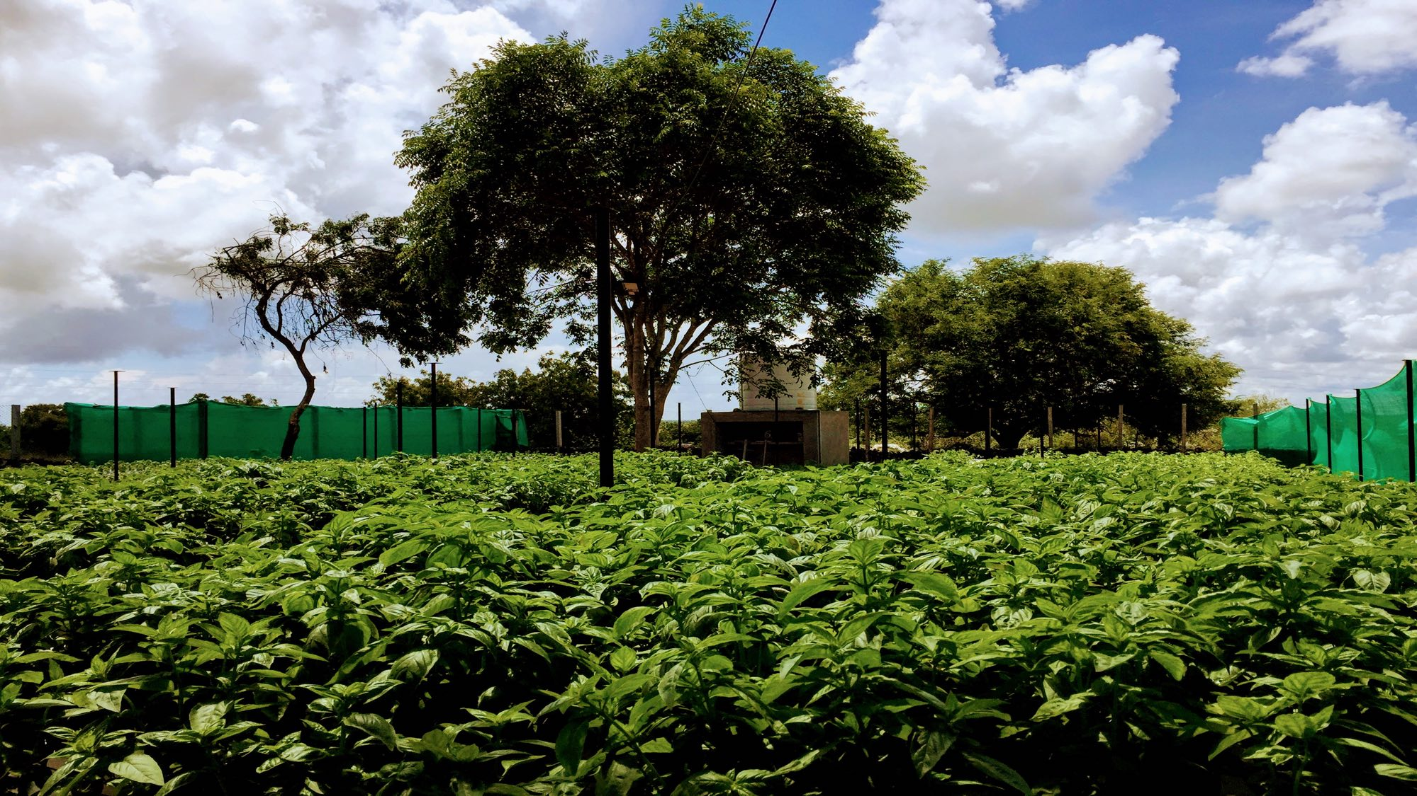
Our work is rooted in traditional organic farming practices, but integrated to latest technologies for increasing profitability for small and marginal farmers by:
- increasing yield through smart and precision agriculture technologies.
- bringing in well-established management practices to increase efficiency and mitigate risks at each step of the value chain, starting from the preventable losses at farm level.

The core model is that of a “Food-Forest” where we grow 20-25 different types of vegetables, greens, fruits and herbs in every acre of land in a scientific manner. With a simple but well-planned design, the food -forest model can yield 15-18 tons of vegetables and fruits per acre per year.

We are working to develop a standard model that can be replicated, with suitable adaptations, across any agro-climatic zone in the country.

An End-to-end Model for Organic Farming

The business model combines the two ends of the entire value chain of organic farming. At the production end, we are working to develop high-yield organic farms with ex-soldiers as grassroot leaders and at the other, we are creating the sales channels directly to home customers under our Sainya Krishi brand with a tagline “We are your Family Farmers”.

Figure 1: Schema of the end-to-end Model for Organic Farming Business

Pre-Production
This is the first stage of our business that involves screening, selection and training of ex-servicemen (ESM). We also select and work on taking farmlands on lease for organic farming in this stage.

Production
In this stage, the focus is on high-yield, high-density organic production using our Food Forest Model

Post-Production
Here, the collection, sorting, grading and packing is undertaken for sales to our customers.
Invariably, about 15-20% of the vegetables and greens are not sold.
There are two approaches to minimise wastage and to earn revenue from these unsold produce:
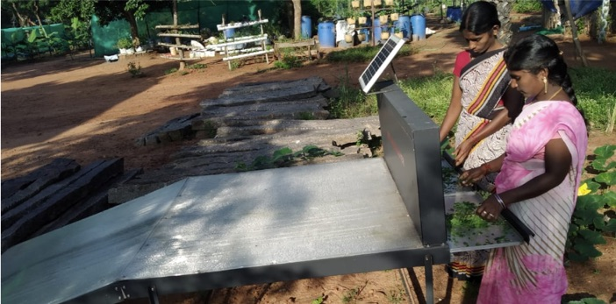
- Solar Drying of vegetables. There are two direct benefits – minimal wastage and increase the shelf life of the solar-dried products to over six months. The value associated with solar dried products is high. It is a very good supplementary business, aligned to the main business of organic products sale.
- Gratitude Kitchen. Using our farm produce, we have been able to produce a line of healthy juices, salads and sandwiches, that are in fairly high demand from customers.

Approach to Sales: Sainya Krishi - We are your Family Farmers
To get the best value for the organic produce, we have setup a direct-to-consumer service. It is very feasible if the farms are within 100-150 km of a city. Gratitude Farms has setup such a service under its brand name, Sainya Krishi with a tagline “We are your family farmers”.

Sourcing organic produce from an ESM’s farm with traceability built-in from farm to fork, helps in building a trust-based business with our customers.

Scaling up to Regional and then National Level
A model training facility is being setup outside Pondicherry with a capacity of 60 residential trainees at any one time. The trainings are designed to be aligned to the National Occupational Standards of NSDC and we are working with reputed Universities and Institutions for certification of our Training Programs,

For scaling up the model to a state level and mobilising ESM to take up organic farming, we are setting up an FPO (Farmer Producer Organisation) exclusively for ESM from six districts of Tamil Nadu.

Starting next month, in order to spread awareness, and to mobilise retiring and retired soldiers, we will be seeking support from Army authorities (DG Resettlement, Area HQs, Regimental Centres, Army Placement Nodes, DIAV and so on) and organisations like Rajya Sainik Board, Zilla Sainik Board and so on.

Conclusion
Wealth creation and employment generation for ESM in rural areas through organic farming is central to Gratitude Farms’ approach. Our work is rooted in traditional organic farming practices but integrated with latest technologies, management practices to increase yield (and hence economic viability for marginal farmers), scalability and replicability.

Helping ESM become successful organic farming entrepreneurs at large scale goes beyond just dignified livelihood for them. They are a natural fit, given their potential leadership abilities, to become change leaders at grass-root level and help transform their villages towards sustainable, environment friendly, economic success.

About the Author:
Major VP Sharma (Retd): Co-Founder and CEO
Major VP Sharma (Retd) has over 34 years of technology experience. He served in Indian Army (Corps of Signals) for 16 years from 1985 to 2001.
He transitioned to corporate world in 2001. For the next 16 years, he worked for Airtel, Ericsson, Nokia and Cisco Systems in senior positions.

In 2017, he left his corporate career and along with three of his close friends to take up social entrepreneurship full-time through two ventures - Gramonnati Trust and Gratitude Farms with a goal to develop 10,000 rural entrepreneurs over the next five years from amongst youth, women and ex-soldiers.
He lives in Pondicherry.
He is an alumnus of National Defence Academy, Khadakvasla and IIT Kanpur (M Tech, EE)
LinkedIn: https://www.linkedin.com/in/vpsharma/

He can be reached at vpsharma@gratitudfarms.co.in

